**ASSIGNMENT-8**

U19CS012

**1.** Design a Clamper to perform the following operation.



Answer :

Since the Waveform is *Shifted Downwards*, **Negative** Clipper Must be used.

But, the Waveform needs to be Shifted Slightly Upward by 2.7 V

[Forward Bias = 2V + 0.7V [Diode]]

*1.) Circuit Image:*

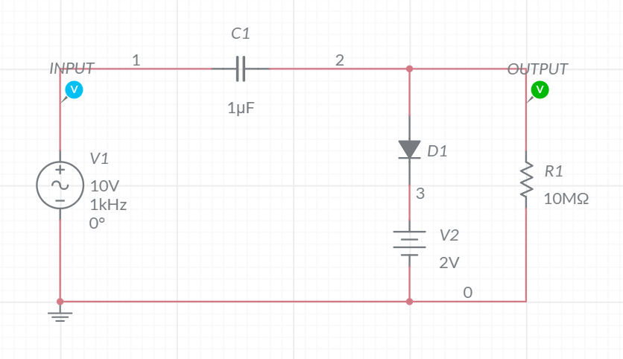

*2.) Grapher Image:*

